Harambe’s Revenge

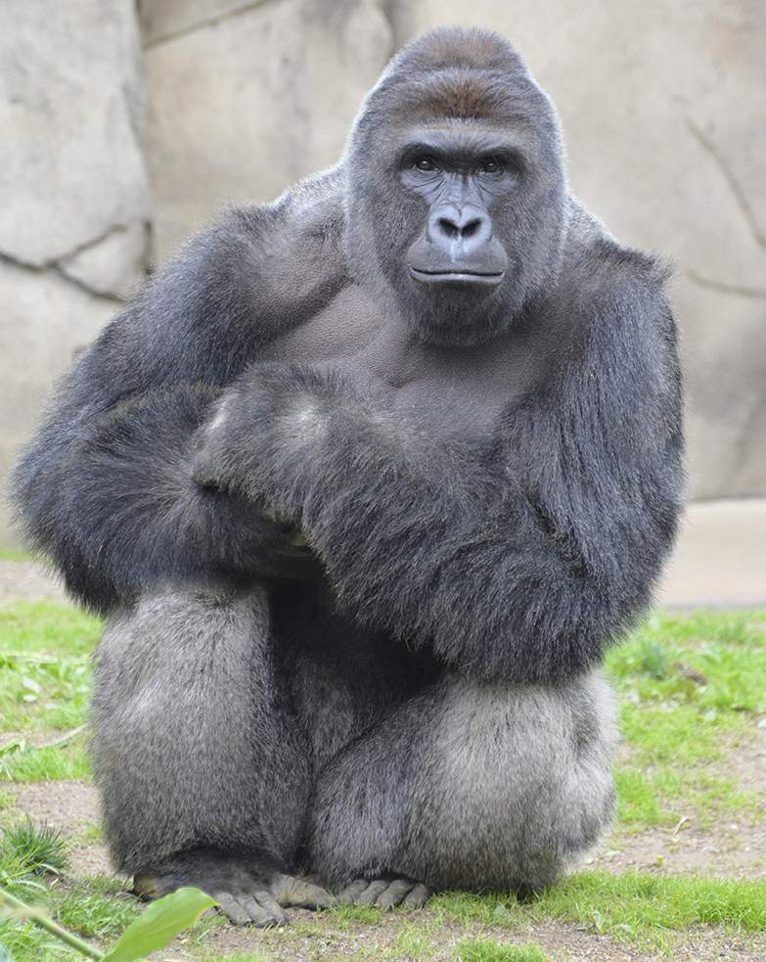

Table of Contents

Genre 2

System Requirements 2

Game Mechanics 2

Game Story 2

Game Controls & User Interface 2

Monetization 2

Replayability 2

Sequel 2

Inspirations & Examples 2

Asset List 3

Genre

Harambe’s Revenge will be an action, arcade game.

System Requirements

This game is aimed to be released on PC, and should run fine with standard specs. We don’t have any plans to port it to make it compatible with mobile or console yet.

Game Mechanics

The player plays as Harambe the gorilla in a 3D world, with perhaps some 2D assets. The player will move around the environment trying to destroy as much of it as possible. The more the player destroys the larger Harambe will grow. As Harambe grows larger he will “level up “ in class and be able to destroy larger classes of objects.

-Class 1 Objects

- Adult Human sized or smaller

-Class 2 Objects

- Car sized or smaller

-Class 3 Objects

-Elephant sized or smaller

-Class 4 Objects

-Small buildings or smaller

-Class 5 objects

-Regular sized buildings or smaller

Game Story

Harambe the gorilla was shot and killed after trying to protect a young human boy who fell into his enclosure. Something has happened and Harambe the gorilla is back. This is the story of Harmbe’s Revenge.

Game Controls & User Interface

The player can move with the WASD keys and look around with the mouse and the camera will be in a third person perspective with a possible option of first person. The left and right mouse buttons will allow the player to attack and destroy the environment. There will also be a score displayed for the amount of points obtained.

Monetization

If we chose to monetize the game we may have the game be sold for $5-$10 or it may even be free to play with optional skins or character models available for purchase.

Replayability

The replayability will mostly be for those who want to achieve a higher score or to more thoroughly destroy the environment.

Sequel

There are no plans to make a sequel. A sequel for a game like this would be difficult unless if its more of the same, but in different environments. If it is successful we would definitely consider making a sequel with new environments to destroy and explore.

Inspirations & Examples

This game’s gameplay is heavily inspired by Katamari. Katamari is a game where you start with a small ball and roll up as many items as you can to grow larger

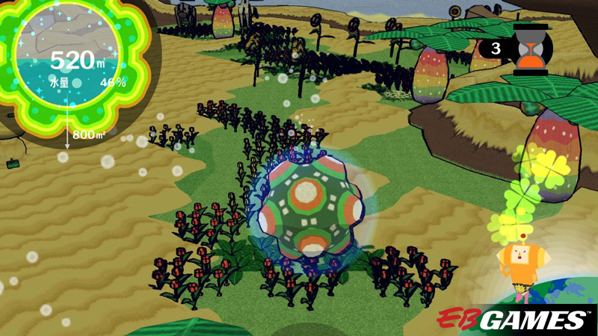

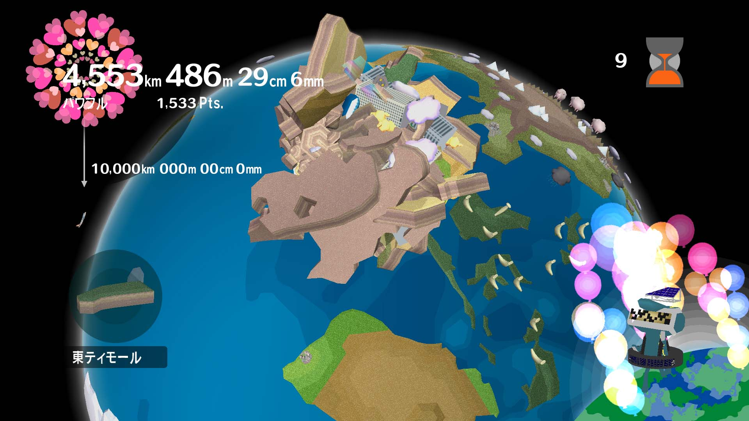

Our game is also inspired by the game Rampage for its theme and destructible environment.

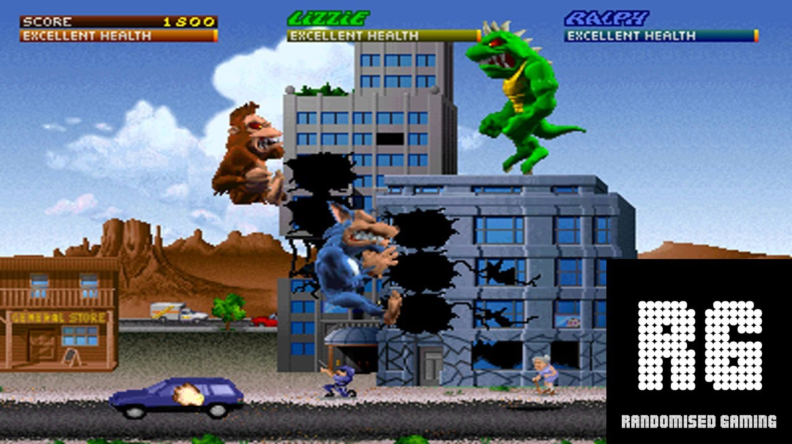

Asset List

A list or art and music assets that are needed for the game, be as specific as possible, include animations, different sound effects, variations in art this will help the artists and music designers see what exactly they will need to prepare for. This list is also not set in stone and can change as development goes on, but it is good to have a decent amount of de